**Nerve tissue, synapses, and neurotransmitters**

**Last edited: Sep 29, 2022**

[Content policy](https://support.amboss.com/hc/en-us/articles/6365572887188-AMBOSS-Content-Policy)

**QBANK SESSION**

**LEARNED**

**Summary**

[Nerve tissue](https://next.amboss.com/us/article/lp0vpS#Z196e86ab42d1b8355c00fce2eefec134) consists of [neurons](https://next.amboss.com/us/article/lp0vpS#Zeb508d67af399f2b2da18e8b2cc5eed8), which are excitable cells that transmit information as electrical signals, and [glial cells](https://next.amboss.com/us/article/lp0vpS#Z0141b87aed6e35dbc01acec20bfa41a8) (e.g., [oligodendrocytes](https://next.amboss.com/us/article/lp0vpS#Ze19e0f996183087b078d8ee362b30d94), [Schwann cells](https://next.amboss.com/us/article/lp0vpS#Z78a00632913a355d308efa4097fd3fc6), [astrocytes](https://next.amboss.com/us/article/lp0vpS#Z278f1014139b0ab220fa3519fa05a6e1), [microglial cells](https://next.amboss.com/us/article/lp0vpS#Zaa36068e5fec42631775262c2f1d6afa)), which perform a variety of nonsignaling functions such as forming [myelin](https://next.amboss.com/us/article/lp0vpS#Z5c8a0a205a24fdf1ccd326f18250fbe1) to provide support and insulation between [neurons](https://next.amboss.com/us/article/lp0vpS#Zeb508d67af399f2b2da18e8b2cc5eed8), phagocytosing and removing cellular debris, removing excess [neurotransmitters](https://next.amboss.com/us/article/lp0vpS#Z52019f1f39ac49ccfe9ec7e865d1766d), and forming the [blood-brain](https://next.amboss.com/us/article/WK0P2S#Z7275a8591b84cb1a26d6d9701b7e96cb) barrier. [Oligodendrocytes](https://next.amboss.com/us/article/lp0vpS#Ze19e0f996183087b078d8ee362b30d94) myelinate [neurons](https://next.amboss.com/us/article/lp0vpS#Zeb508d67af399f2b2da18e8b2cc5eed8) in the [central nervous system](https://next.amboss.com/us/article/lp0vpS#Z0111aade770ed6f7d136b455de1d6c1f) ([CNS](https://next.amboss.com/us/article/lp0vpS#Z0111aade770ed6f7d136b455de1d6c1f)), while [Schwann cells](https://next.amboss.com/us/article/lp0vpS#Z78a00632913a355d308efa4097fd3fc6) myelinate [neurons](https://next.amboss.com/us/article/lp0vpS#Zeb508d67af399f2b2da18e8b2cc5eed8) in the [peripheral nervous system](https://next.amboss.com/us/article/lp0vpS#Zb88dba1879bd21cc00dcf08e03bab60a) ([PNS](https://next.amboss.com/us/article/lp0vpS#Zb88dba1879bd21cc00dcf08e03bab60a)). [Myelin](https://next.amboss.com/us/article/lp0vpS#Z5c8a0a205a24fdf1ccd326f18250fbe1) sheaths increase the conduction velocity of signals across [axons](https://next.amboss.com/us/article/lp0vpS#Z7a7039b9bbc6353245e697e51712c2c4). [Inflammation](https://next.amboss.com/us/article/j50_Pg#Za5de83449ff6a749e6c1348b93b1f3b1) and loss of the [myelin](https://next.amboss.com/us/article/lp0vpS#Z5c8a0a205a24fdf1ccd326f18250fbe1) sheath are the underlying pathologic processes in [multiple sclerosis](https://next.amboss.com/us/article/WR0PNf#Z31360d67aa0be6b83f52c446fd30c0c1) ([CNS](https://next.amboss.com/us/article/lp0vpS#Z0111aade770ed6f7d136b455de1d6c1f)) and Guillain barre syndrome ([PNS](https://next.amboss.com/us/article/lp0vpS#Zb88dba1879bd21cc00dcf08e03bab60a)). [Neurons](https://next.amboss.com/us/article/lp0vpS#Zeb508d67af399f2b2da18e8b2cc5eed8) are composed of [dendrites](https://next.amboss.com/us/article/lp0vpS#Z3e8773a5d2f360213b09c01c950245f3), cell bodies, [axons](https://next.amboss.com/us/article/lp0vpS#Z7a7039b9bbc6353245e697e51712c2c4), and [axon](https://next.amboss.com/us/article/lp0vpS#Z7a7039b9bbc6353245e697e51712c2c4) terminals. Based on their conduction velocity, diameter, and myelination, nerve fibers ([axons](https://next.amboss.com/us/article/lp0vpS#Z7a7039b9bbc6353245e697e51712c2c4)) are classified into large, myelinated fibers with fast conduction velocity (group A); small, myelinated fibers with slow conduction velocity (group B); and small, unmyelinated fibers with slow conduction velocity (group C). [Neurons](https://next.amboss.com/us/article/lp0vpS#Zeb508d67af399f2b2da18e8b2cc5eed8) communicate through the transmission of [action potentials](https://next.amboss.com/us/article/9o0NVS#Z0988f6842348a3c63311140c08a28497) across junctions between them called [synapses](https://next.amboss.com/us/article/lp0vpS#Zdcd1055abed8e01dc833605f76cb61ae). [Synaptic transmission](https://next.amboss.com/us/article/lp0vpS#Z1bfc0864fad66774968660d4edf6f55a) can be chemical or electrical. Chemical [synaptic transmission](https://next.amboss.com/us/article/lp0vpS#Z1bfc0864fad66774968660d4edf6f55a) is the transfer of signals through the release of [neurotransmitters](https://next.amboss.com/us/article/lp0vpS#Z52019f1f39ac49ccfe9ec7e865d1766d) (e.g. [acetylcholine](https://next.amboss.com/us/article/lp0vpS#Z3c3ab1c3772cabdb26be3c413ba52df4), [dopamine](https://next.amboss.com/us/article/tN0X1g#Z0db70cd20a4945b51725d7adce664557), [norepinephrine](https://next.amboss.com/us/article/lp0vpS#Z3c0eaeb56003161b0a4d01de1c8dcdc9)) from presynaptic terminals to postsynaptic [receptors](https://next.amboss.com/us/article/qo0C1S#Z3ff0122a3c004eebed96e9db47e16ea4). Electrical [synaptic transmission](https://next.amboss.com/us/article/lp0vpS#Z1bfc0864fad66774968660d4edf6f55a) is the transfer of electrical signals through [gap junctions](https://next.amboss.com/us/article/Lo0wcS#Zb203dadec51ca5c9c73e4468fb336a6c). Alterations in [neurotransmitter](https://next.amboss.com/us/article/lp0vpS#Z52019f1f39ac49ccfe9ec7e865d1766d) levels have been observed in various neurological diseases, including [Parkinson disease](https://next.amboss.com/us/article/C30qkf#Zab69cf8e484a0b848765347ea6dc1cd7) (decreased [dopamine](https://next.amboss.com/us/article/tN0X1g#Z0db70cd20a4945b51725d7adce664557)), [schizophrenia](https://next.amboss.com/us/article/pP0LfT#Z2988495da67e41c0dfbd5c9a150e3442) (increased [dopamine](https://next.amboss.com/us/article/tN0X1g#Z0db70cd20a4945b51725d7adce664557)), depression (decreased [dopamine](https://next.amboss.com/us/article/tN0X1g#Z0db70cd20a4945b51725d7adce664557), [norepinephrine](https://next.amboss.com/us/article/lp0vpS#Z3c0eaeb56003161b0a4d01de1c8dcdc9), and [serotonin](https://next.amboss.com/us/article/lp0vpS#Z66351ff66c1492921628337667462b5a)), and [Alzheimer disease](https://next.amboss.com/us/article/D301kf#Z871d1bb7a791c1b1b4a1351d40ed3cd0) (decreased [acetylcholine](https://next.amboss.com/us/article/lp0vpS#Z3c3ab1c3772cabdb26be3c413ba52df4)).

https://www.youtube.com/watch?v=Jru5dJXrPR4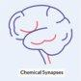

**Nerve tissue**

**General**

* [Nerve tissue](https://next.amboss.com/us/article/lp0vpS#Z196e86ab42d1b8355c00fce2eefec134) is the main tissue component of the nervous system and is primarily composed of [neurons](https://next.amboss.com/us/article/lp0vpS#Zeb508d67af399f2b2da18e8b2cc5eed8) and supporting [glial cells](https://next.amboss.com/us/article/lp0vpS#Z0141b87aed6e35dbc01acec20bfa41a8).
* The nervous system is divided into two main components:
  + **Central nervous system** ([CNS](https://next.amboss.com/us/article/lp0vpS#Z0111aade770ed6f7d136b455de1d6c1f)): consists of the brain and spinal cord
  + **Peripheral nervous system**: consists of the nerves and [ganglia](https://next.amboss.com/us/article/560ilS#Z6294d6fa1c5c81f5f7a565e8cb39567c) outside the brain and spinal cord, including the [cranial nerves](https://next.amboss.com/us/article/tR0XKf#Zb1add780aa11ae45ecd515d8aada4292), [spinal nerves](https://next.amboss.com/us/article/G60BmS#Zc45b13f484edbf4ea16cf2c359124b5e), and their roots, [peripheral nerves](https://next.amboss.com/us/article/lp0vpS#Zb88dba1879bd21cc00dcf08e03bab60a), and neuromuscular junctions

**Neurons**

* **Description**
  + Polarized, signal-transmitting cells that comprise the central and [peripheral nervous system](https://next.amboss.com/us/article/lp0vpS#Zb88dba1879bd21cc00dcf08e03bab60a)
  + Classified into unipolar, pseudounipolar, bipolar, and multipolar depending on the number of protoplasmic processes (neurites)
  + Do not undergo [mitosis](https://next.amboss.com/us/article/Mo0McS" \l "Z8df00e166ee4f3f06d0d108c2ab91db6)
  + Composed of [soma](https://next.amboss.com/us/article/lp0vpS#Z072bb8617327712cabe88097f2c1dba7) (cell body), [axon](https://next.amboss.com/us/article/lp0vpS#Z7a7039b9bbc6353245e697e51712c2c4) and [dendrites](https://next.amboss.com/us/article/lp0vpS#Z3e8773a5d2f360213b09c01c950245f3)
  + [Nissl staining](https://next.amboss.com/us/article/Lo0wcS#Z8174f6711634ee5b6e9ab649c5bb558f) positive in [the cell](https://next.amboss.com/us/article/Lo0wcS#Z0b2dbba84cd425084862e30873efee1a) body and [dendrites](https://next.amboss.com/us/article/lp0vpS#Z3e8773a5d2f360213b09c01c950245f3), which have [Nissl substance](https://next.amboss.com/us/article/Lo0wcS#Z574e04d3b783927e028982e71467bf13) (aggregates of [rough endoplasmic reticulum](https://next.amboss.com/us/article/Lo0wcS#Zd26f841cd34fce6b673bd4e0f3fed487) with bound [polysomes](https://next.amboss.com/us/article/Jo0s1S#Z348da8d53eef840b25d08da3f236972c))
* **Parts**
  + **Soma**: contains [the cell](https://next.amboss.com/us/article/Lo0wcS" \l "Z0b2dbba84cd425084862e30873efee1a) organelles
    - Has [Nissl substance](https://next.amboss.com/us/article/Lo0wcS" \l "Z574e04d3b783927e028982e71467bf13)
    - Pigments: [melanin](https://next.amboss.com/us/article/W60PPS" \l "Z58a27ebac9eef256c520ba65eaadd468), [lipofuscin](https://next.amboss.com/us/article/VP0GdT" \l "Z9dfa90b47fb5223ad397e9ba918a6301)
    - [Cytoskeleton](https://next.amboss.com/us/article/Lo0wcS#Z75bdf53ae8f417fea17bf8dbc9df7b77): microfilaments
  + **Axon**: the projection from a [neuron](https://next.amboss.com/us/article/lp0vpS#Zeb508d67af399f2b2da18e8b2cc5eed8)'[s cell](https://next.amboss.com/us/article/eJ0xGS#Z3a87b26a5d0016146c42f205ce7d426d) body along which [action potentials](https://next.amboss.com/us/article/9o0NVS#Z0988f6842348a3c63311140c08a28497) travel to **send intercellular signals**
    - Connected to [the cell](https://next.amboss.com/us/article/Lo0wcS#Z0b2dbba84cd425084862e30873efee1a) body at the axon hillock, which is a trigger zone for initiation of [action potentials](https://next.amboss.com/us/article/9o0NVS#Z0988f6842348a3c63311140c08a28497) , and ends in a [synapse](https://next.amboss.com/us/article/lp0vpS#Zdcd1055abed8e01dc833605f76cb61ae)
    - Lacks a regular [rough endoplasmic reticulum](https://next.amboss.com/us/article/Lo0wcS#Zd26f841cd34fce6b673bd4e0f3fed487) and thus does not contain [Nissl substance](https://next.amboss.com/us/article/Lo0wcS#Z574e04d3b783927e028982e71467bf13)  [1]
    - [Cytoskeleton](https://next.amboss.com/us/article/Lo0wcS#Z75bdf53ae8f417fea17bf8dbc9df7b77)
      * [Microtubules](https://next.amboss.com/us/article/Lo0wcS#Ze5f7ee56e0fca05cfe183570be1173eb) with associated motor [proteins](https://next.amboss.com/us/article/8K0ORS#Z6dee07cab92e13d1f6baa3a3ce402f23) for rapid axonal transport
        + [**Kinesin**](https://next.amboss.com/us/article/Lo0wcS#Z767191224edb322dd77c20a54992492d)**: anterograde transport** (– → +)
        + [**Dynein**](https://next.amboss.com/us/article/Lo0wcS#Z4769246ca3c7bfef0b2046ceb8286c33)**: retrograde transport** (+ → –)
      * [Neurofilaments](https://next.amboss.com/us/article/ol00BT#Z8fd97e237773f476b997212c4d421c12)
        + Provide structural support
        + Most abundant in [axons](https://next.amboss.com/us/article/lp0vpS#Z7a7039b9bbc6353245e697e51712c2c4) and the [proximal](https://next.amboss.com/us/article/xo0EVS#Z3538c7d0d3c09a64652ecccc7971d5ae) part of [dendrites](https://next.amboss.com/us/article/lp0vpS#Z3e8773a5d2f360213b09c01c950245f3)
        + [Neurofilament](https://next.amboss.com/us/article/ol00BT#Z8fd97e237773f476b997212c4d421c12) protein is used as a marker for neuronal cells.
  + **Dendrites**
    - Branching, thin projections from [the cell](https://next.amboss.com/us/article/Lo0wcS#Z0b2dbba84cd425084862e30873efee1a) body of [neurons](https://next.amboss.com/us/article/lp0vpS#Zeb508d67af399f2b2da18e8b2cc5eed8) that **receive input** from neighboring [neurons](https://next.amboss.com/us/article/lp0vpS#Zeb508d67af399f2b2da18e8b2cc5eed8) and transmit it to [the cell](https://next.amboss.com/us/article/Lo0wcS#Z0b2dbba84cd425084862e30873efee1a) body
    - Contain spines that increase the number of [synapses](https://next.amboss.com/us/article/lp0vpS#Zdcd1055abed8e01dc833605f76cb61ae) to other [neurons](https://next.amboss.com/us/article/lp0vpS#Zeb508d67af399f2b2da18e8b2cc5eed8)
    - Have [Nissl substance](https://next.amboss.com/us/article/Lo0wcS" \l "Z574e04d3b783927e028982e71467bf13)
    - [Cytoskeleton](https://next.amboss.com/us/article/Lo0wcS#Z75bdf53ae8f417fea17bf8dbc9df7b77): microfilaments

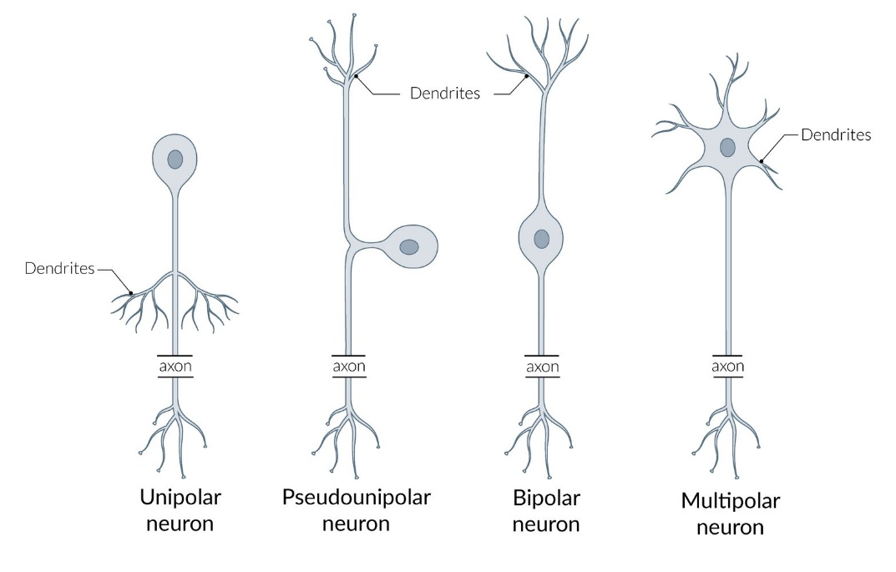 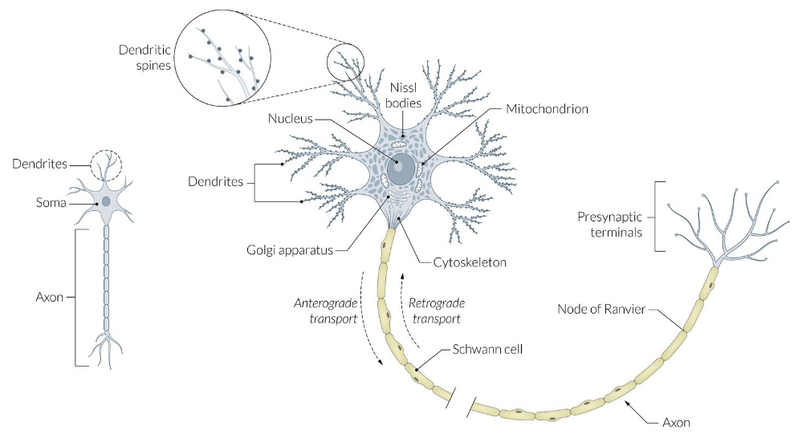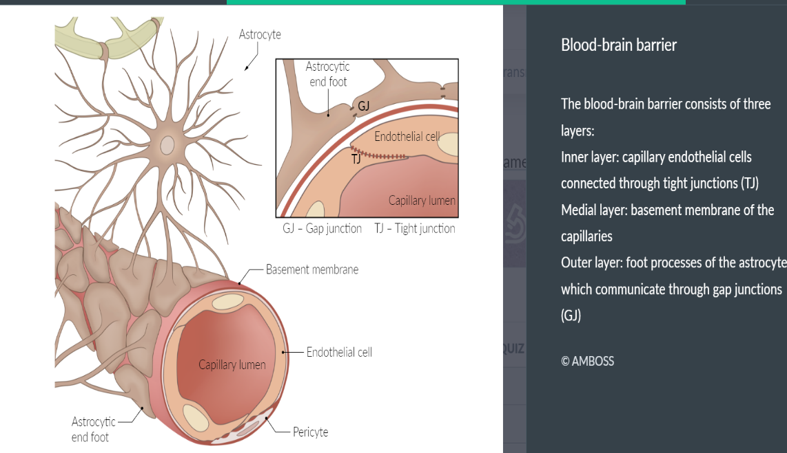 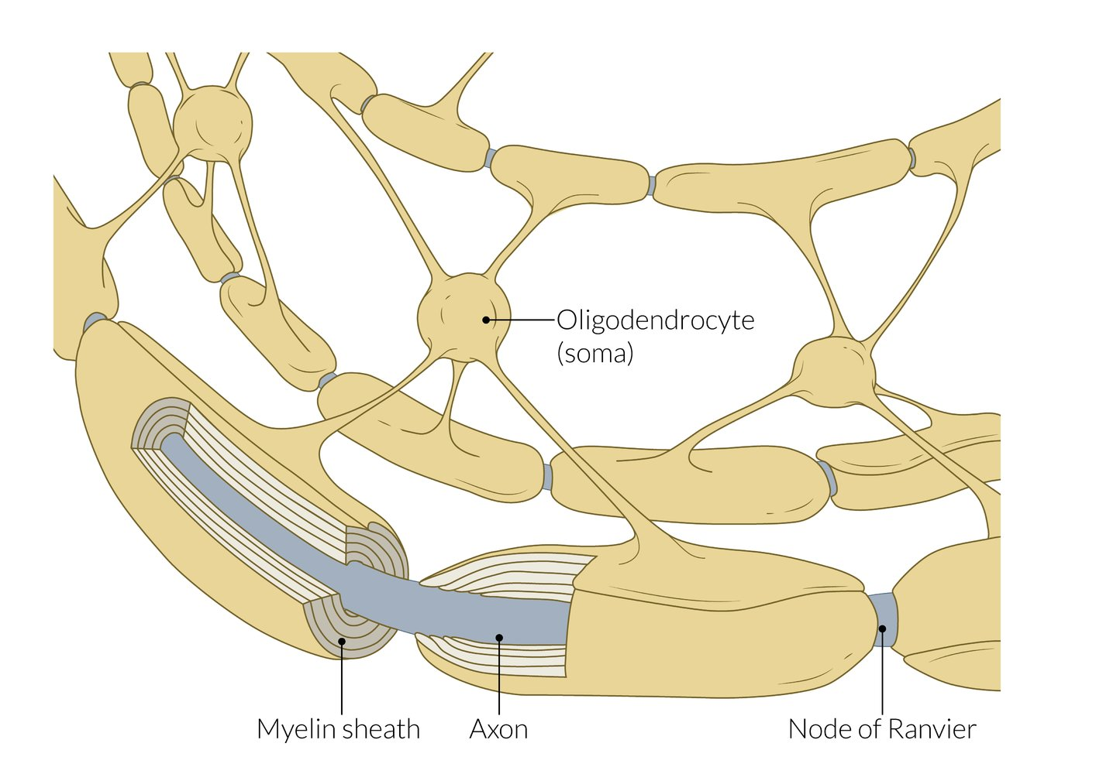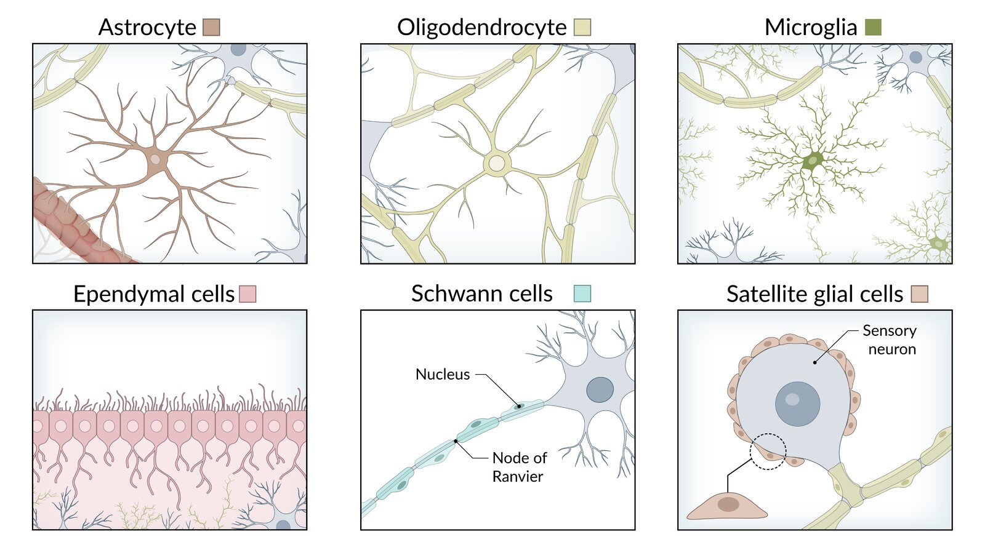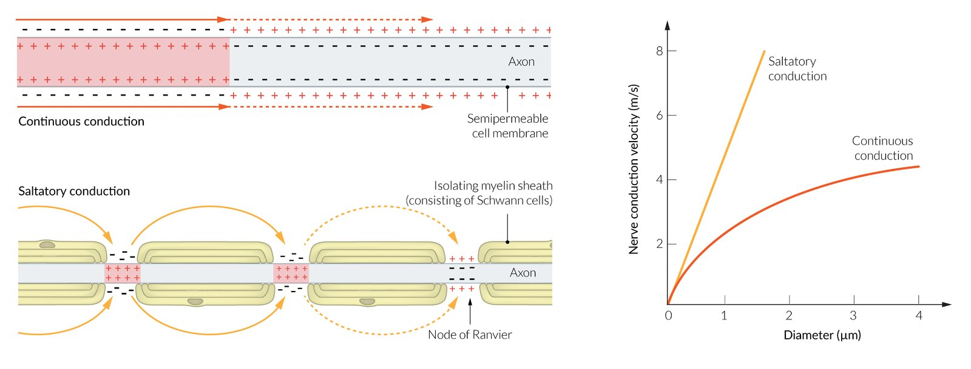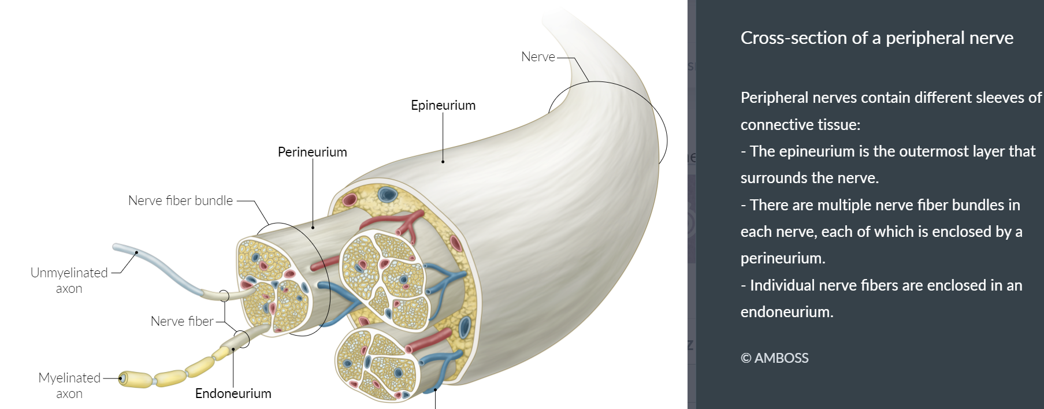

**Supporting glial cells**

MAXIMIZE TABLETABLE QUIZ

| **Cells of [nerve tissue](https://next.amboss.com/us/article/lp0vpS" \l "Z196e86ab42d1b8355c00fce2eefec134)** | | | |
| --- | --- | --- | --- |
| **Structure** | **Precursor** | **Characteristics** | **Clinical relevance** |
| **Central** | | | |
| **Astrocytes** | * Radial glial cells from neuroepithelium ([neuroectoderm](https://next.amboss.com/us/article/vo0AdS#Z0cb41b8782c335c967d428473aaa18e8)) | * Most abundant type of [glial cells](https://next.amboss.com/us/article/lp0vpS#Z0141b87aed6e35dbc01acec20bfa41a8) * Have a large number of projections * Provide physical support (scaffolding of the [CNS](https://next.amboss.com/us/article/lp0vpS#Z0111aade770ed6f7d136b455de1d6c1f)) * Provide extracellular potassium buffer * Remove excess [neurotransmitters](https://next.amboss.com/us/article/lp0vpS" \l "Z52019f1f39ac49ccfe9ec7e865d1766d) * Contain [glycogen](https://next.amboss.com/us/article/t60X5S" \l "Z2f3d6c65626472b77ed6d3a5af41ea01) reserve * Contain bundles of [intermediate filaments](https://next.amboss.com/us/article/Lo0wcS#Z6d8111343057a64286a1f0274e7091bb) composed of [glial fibrillary acidic protein](https://next.amboss.com/us/article/ol00BT#Za078e8b2fe4c844e24f59c73ee6e7a4a) ([**GFAP**](https://next.amboss.com/us/article/ol00BT#Za078e8b2fe4c844e24f59c73ee6e7a4a); an [astrocyte](https://next.amboss.com/us/article/lp0vpS#Z278f1014139b0ab220fa3519fa05a6e1) marker) * Proliferate and become [hypertrophic](https://next.amboss.com/us/article/VP0GdT#Z2565f5179622b57d8e166369a90801a0) after [CNS](https://next.amboss.com/us/article/lp0vpS#Z0111aade770ed6f7d136b455de1d6c1f) injury   + Involved in nervous tissue repair   + Reactive gliosis → form of astroglial scars * Foot processes form part of the [**blood-brain**](https://next.amboss.com/us/article/WK0P2S#Z7275a8591b84cb1a26d6d9701b7e96cb)**barrier** and the glial-limiting membrane | * [Astrocytoma](https://next.amboss.com/us/article/H50Klg#Z66ba4ce9d7c53598f7da26cde1c8025f) |
| **Microglia** | * [Bone marrow](https://next.amboss.com/us/article/ln0vtg#Zba672ce639f8a71189c3b29114401a54) [monocytes](https://next.amboss.com/us/article/ln0vtg" \l "Zda9f7bde260c3c626e140df9e1c1a74c) ([mesoderm](https://next.amboss.com/us/article/vo0AdS" \l "Za9a0822ab16d239b5c3a6112dd40a66a)) | * Smallest type of [glial cells](https://next.amboss.com/us/article/lp0vpS" \l "Z0141b87aed6e35dbc01acec20bfa41a8) * Poorly identified with [Nissl stain](https://next.amboss.com/us/article/Lo0wcS" \l "Z8174f6711634ee5b6e9ab649c5bb558f) * [**Phagocytic cells**](https://next.amboss.com/us/article/tM0Xqg#Zb4787786df627f8f7e25b35f1a950263)   + Activated in response to [CNS](https://next.amboss.com/us/article/lp0vpS#Z0111aade770ed6f7d136b455de1d6c1f) tissue damage   + Proliferate and migrate to damaged [CNS](https://next.amboss.com/us/article/lp0vpS#Z0111aade770ed6f7d136b455de1d6c1f) to remove cellular debris   + Release inflammatory mediators (e.g., [nitric oxide](https://next.amboss.com/us/article/qo0C1S#Z6e41007f5cfe26f595a9a8859b96a31c)) and signaling molecules (e.g., [glutamate](https://next.amboss.com/us/article/lp0vpS#Z0555ea6b157157d3843b24e686403f7f)) | * [Target cells](https://next.amboss.com/us/article/WS0PA2#Zcc652cbd7322c252dc18d5d510740f9e) for the [HIV-1](https://next.amboss.com/us/article/mf0V52#Z2232db6f7c8cb8fc7846fb5efc8c3999) [virus](https://next.amboss.com/us/article/Pn0Wtg#Zcdc83877f75d9d9b9a07ece6544f646c): Infected cells fuse to form [multinucleated giant cells](https://next.amboss.com/us/article/VP0GdT#Z8148fba61325d18ed62206940d4cf388), which are the most specific histological marker of [HIV](https://next.amboss.com/us/article/mf0V52#Z318c3fdbcf10c252f3453a2394e29d91) [encephalitis](https://next.amboss.com/us/article/rs0fwh#Zda468caf35fa54ceb1f3edaba0da1cfe) and [HIV-associated dementia](https://next.amboss.com/us/article/1o02aS#Z3364208d1d95481ff066d41645ef9d0e). [2] |
| **Ependymal cells (ependymocytes) and**[**choroid**](https://next.amboss.com/us/article/cp0aoS#Z2fb971060aa57f733ceabaa091c9c236)[**epithelial**](https://next.amboss.com/us/article/Io0YWS#Z23c08800c35f1f71236b85bd916db48b)**cells** | * Neuroepithelial cells ([neuroectoderm](https://next.amboss.com/us/article/vo0AdS" \l "Z0cb41b8782c335c967d428473aaa18e8)) | * Simple columnar [glial cells](https://next.amboss.com/us/article/lp0vpS" \l "Z0141b87aed6e35dbc01acec20bfa41a8) * Form the [epithelium](https://next.amboss.com/us/article/Io0YWS#Z23c08800c35f1f71236b85bd916db48b) lining the ventricles and central canal of the spinal cord * Apical surface   + Cilia circulate [CSF](https://next.amboss.com/us/article/WK0P2S#Zada05eaaf90f5ec68b357c7060eddf73)   + [Microvilli](https://next.amboss.com/us/article/Io0YWS#Z6062111b4e7cc07997b616d30635bc47) increase the capacity of [CSF](https://next.amboss.com/us/article/WK0P2S#Zada05eaaf90f5ec68b357c7060eddf73) absorption * Modified [ependymal cells](https://next.amboss.com/us/article/lp0vpS#Z2e9f63af8b1463a0e1912dd01e5e8cea) known as the [choroid plexus](https://next.amboss.com/us/article/WK0P2S#Z9556df5fa4ed5b8ab5940c1638b61d23) produce [cerebrospinal fluid](https://next.amboss.com/us/article/WK0P2S#Zada05eaaf90f5ec68b357c7060eddf73) | * [Ependymoma](https://next.amboss.com/us/article/H50Klg#Zb05d33ff6d9c4d388ba321e857894331) |
| **Tanycytes** | * Radial glial cells from neuroepithelium ([neuroectoderm](https://next.amboss.com/us/article/vo0AdS#Z0cb41b8782c335c967d428473aaa18e8)) | * Transport substances between the blood and the ventricles * Located mainly on the floor of the [third ventricle](https://next.amboss.com/us/article/WK0P2S#Z2bd9b803d839dbf86d1c382e00cd015c), in contact with [hypothalamic](https://next.amboss.com/us/article/-60DnS#Z90567581e440893e2c4839a28332f0cf) [neurons](https://next.amboss.com/us/article/lp0vpS#Zeb508d67af399f2b2da18e8b2cc5eed8) * Play a role in glucose homeostasis | * Metabolic diseases (e.g., [type 2 diabetes](https://next.amboss.com/us/article/3g0SE2#Z53b90a4cadc0e1319152d8c973fff7e4)) [3] |
| **Oligodendrocytes** | * Neuroepithelial cells ([neuroectoderm](https://next.amboss.com/us/article/vo0AdS" \l "Z0cb41b8782c335c967d428473aaa18e8)) | * Myelinate [axons](https://next.amboss.com/us/article/lp0vpS#Z7a7039b9bbc6353245e697e51712c2c4) in the [CNS](https://next.amboss.com/us/article/lp0vpS#Z0111aade770ed6f7d136b455de1d6c1f), including [CN II](https://next.amboss.com/us/article/tR0XKf#Z10563771c184f2ce534a98372dc51b89) * Main [glial cells](https://next.amboss.com/us/article/lp0vpS#Z0141b87aed6e35dbc01acec20bfa41a8) in the cerebral [white matter](https://next.amboss.com/us/article/G60BmS#Z6033c93dc0e1193696f0ff56b7d073a9) * Each projection of a cell can myelinate several [axons](https://next.amboss.com/us/article/lp0vpS#Z7a7039b9bbc6353245e697e51712c2c4) (30 on average, up to 60). [4] * Increase speed of conduction and [saltatory conduction](https://next.amboss.com/us/article/9o0NVS#Z65abd3610cc08ab0b403e3dc4daad1bb) * Fried-egg appearance on [histology](https://next.amboss.com/us/article/Io0YWS#Z1f24d210123bdab6ab0bcb4489453103): prominent nucleus and clear, pale [cytoplasm](https://next.amboss.com/us/article/Lo0wcS#Z9f6ca1a93d178d68528ffbdbe09e407b) * Unmyelinated [axons](https://next.amboss.com/us/article/lp0vpS#Z7a7039b9bbc6353245e697e51712c2c4) are not covered by [oligodendrocyte](https://next.amboss.com/us/article/lp0vpS#Ze19e0f996183087b078d8ee362b30d94) [cytoplasm](https://next.amboss.com/us/article/Lo0wcS#Z9f6ca1a93d178d68528ffbdbe09e407b). | * [Oligodendroglioma](https://next.amboss.com/us/article/H50Klg#Z23c2348d4164a056d3d21060fca7be88) * [Multiple sclerosis](https://next.amboss.com/us/article/WR0PNf#Z31360d67aa0be6b83f52c446fd30c0c1) * [Progressive multifocal leukoencephalopathy](https://next.amboss.com/us/article/CH0qsh#Z3532ee676d13916210e903ff4d85c04f) ([PML](https://next.amboss.com/us/article/CH0qsh#Z3532ee676d13916210e903ff4d85c04f)) |
| **Peripheral** | | | |
| **Schwann cells** | * [Neural crest cells](https://next.amboss.com/us/article/vo0AdS#Zce976ac5adb92ec37d4cb7a8de1eef78) ([ectoderm](https://next.amboss.com/us/article/vo0AdS" \l "Za19d7b71841bedfa0474edb2ce631853)) | * Myelinate [axons](https://next.amboss.com/us/article/lp0vpS#Z7a7039b9bbc6353245e697e51712c2c4) of the [PNS](https://next.amboss.com/us/article/lp0vpS#Zb88dba1879bd21cc00dcf08e03bab60a), including [CN III](https://next.amboss.com/us/article/tR0XKf#Zf93de13b5536af7dcc148ee0b926bc14)–XII * Each cell can myelinate one single internodal segment for one single [axon](https://next.amboss.com/us/article/lp0vpS#Z7a7039b9bbc6353245e697e51712c2c4). * Promote repair after nerve injury [5] * Unmyelinated [axons](https://next.amboss.com/us/article/lp0vpS#Z7a7039b9bbc6353245e697e51712c2c4) are covered by [Schwann cell](https://next.amboss.com/us/article/lp0vpS#Z78a00632913a355d308efa4097fd3fc6) [cytoplasm](https://next.amboss.com/us/article/Lo0wcS#Z9f6ca1a93d178d68528ffbdbe09e407b). * Can [phagocytose](https://next.amboss.com/us/article/Lo0wcS" \l "Z5a9454835d6510d816fc8409dca5efdf) debris after injury * Marker: [S100](https://next.amboss.com/us/article/ol00BT#Zfa003a753346e732d8f02d6199dd2d2c) | * [Guillain-Barré syndrome](https://next.amboss.com/us/article/7R04of#Zf193c1b0b16db4d30e7f29d4e766d3e8) ([GBS](https://next.amboss.com/us/article/Sn0ysg#Z76e90f0f0241b753f713ce00f2dc1f09)) * [Acoustic neuroma](https://next.amboss.com/us/article/H30KPf#Zf32678cf3f63533c3ae910453c96204b) ([vestibular schwannoma](https://next.amboss.com/us/article/H30KPf" \l "Zf32678cf3f63533c3ae910453c96204b)) |

Each myelinating SchwONE cell insulates only ONE [axon](https://next.amboss.com/us/article/lp0vpS#Z7a7039b9bbc6353245e697e51712c2c4).

[Glial cells](https://next.amboss.com/us/article/lp0vpS#Z0141b87aed6e35dbc01acec20bfa41a8) guard the [axons](https://next.amboss.com/us/article/lp0vpS#Z7a7039b9bbc6353245e697e51712c2c4) of the nerve cells as **COPS**: **C**NS [axons](https://next.amboss.com/us/article/lp0vpS#Z7a7039b9bbc6353245e697e51712c2c4) are myelinated by **O**ligodendrocytes; **P**NS [axons](https://next.amboss.com/us/article/lp0vpS#Z7a7039b9bbc6353245e697e51712c2c4) are insulated by **S**chwann cells.



**Myelin**

* **Insulating** layer of modified plasma membrane that wraps around [axons](https://next.amboss.com/us/article/lp0vpS#Z7a7039b9bbc6353245e697e51712c2c4) of nerve in a spiral structure
* **Increases the space constant and the conduction velocity** of signals traveling down [axons](https://next.amboss.com/us/article/lp0vpS#Z7a7039b9bbc6353245e697e51712c2c4)
* Decreases [membrane capacitance](https://next.amboss.com/us/article/9o0NVS#Z8eaec005536c46f3d05b0d79f4f7c31e) and increases [membrane resistance](https://next.amboss.com/us/article/9o0NVS#Zfe699b1a3dd61ff47774b5cf36a37beb)
* **Node of Ranvier**
  + Unmyelinated regions between two adjacent myelinated segments of [axons](https://next.amboss.com/us/article/lp0vpS#Z7a7039b9bbc6353245e697e51712c2c4) in the [CNS](https://next.amboss.com/us/article/lp0vpS#Z0111aade770ed6f7d136b455de1d6c1f) and [PNS](https://next.amboss.com/us/article/lp0vpS#Zb88dba1879bd21cc00dcf08e03bab60a)
  + Contain a large amount of Na+ channels: allows [**saltatory conduction**](https://next.amboss.com/us/article/9o0NVS#Z65abd3610cc08ab0b403e3dc4daad1bb) → increases the velocity of [action potentials](https://next.amboss.com/us/article/9o0NVS#Z0988f6842348a3c63311140c08a28497)
* **Demyelination**: a process in which [myelin](https://next.amboss.com/us/article/lp0vpS#Z5c8a0a205a24fdf1ccd326f18250fbe1) sheaths of nerves become damaged, which impairs electrical conduction
  + Central [demyelination](https://next.amboss.com/us/article/lp0vpS#Z3989c89276a0b832011799ccd3e98f1e) occurs within the [CNS](https://next.amboss.com/us/article/lp0vpS#Z0111aade770ed6f7d136b455de1d6c1f) (e.g., seen with [multiple sclerosis](https://next.amboss.com/us/article/WR0PNf#Z31360d67aa0be6b83f52c446fd30c0c1), [progressive multifocal leukoencephalopathy](https://next.amboss.com/us/article/CH0qsh#Z3532ee676d13916210e903ff4d85c04f), leukodystrophies).
  + Peripheral [demyelination](https://next.amboss.com/us/article/lp0vpS#Z3989c89276a0b832011799ccd3e98f1e) affects the [PNS](https://next.amboss.com/us/article/lp0vpS#Zb88dba1879bd21cc00dcf08e03bab60a) (e.g., seen with [Guillain-Barré syndrome](https://next.amboss.com/us/article/7R04of#Zf193c1b0b16db4d30e7f29d4e766d3e8)).

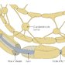

**Neuronal damage**

* **Responses to damage**
  + Cellular swelling
  + Peripherally located nucleus
  + Spread of [Nissl substance](https://next.amboss.com/us/article/Lo0wcS#Z574e04d3b783927e028982e71467bf13) throughout the [cytoplasm](https://next.amboss.com/us/article/Lo0wcS#Z9f6ca1a93d178d68528ffbdbe09e407b) of the [neuron](https://next.amboss.com/us/article/lp0vpS#Zeb508d67af399f2b2da18e8b2cc5eed8) ([**chromatolysis**](https://next.amboss.com/us/article/Zi0ZJf#Zb2338405227f21bd060d5ea66c86ad3e))
  + The [distal](https://next.amboss.com/us/article/xo0EVS#Zce232f978ea5a8fb9edbb980a41502b8) injured part of the [neuron](https://next.amboss.com/us/article/lp0vpS#Zeb508d67af399f2b2da18e8b2cc5eed8) undergoes [**Wallerian degeneration**](https://next.amboss.com/us/article/Zi0ZJf#Z074df13629b4a21ed778e6ab7c0c5f2c).

**Layers of [peripheral nerves](https://next.amboss.com/us/article/lp0vpS" \l "Zb88dba1879bd21cc00dcf08e03bab60a)**

* **Endoneurium**
  + Thin inner layer of [connective tissue](https://next.amboss.com/us/article/ro0fWS#Z237f9be2f72618740135910efab7323f) around a single nerve fiber
  + Clinical significance: contains inflammatory infiltrate in [Guillain-Barre syndrome](https://next.amboss.com/us/article/7R04of#Zf193c1b0b16db4d30e7f29d4e766d3e8)
* **Perineurium**
  + Layer of [connective tissue](https://next.amboss.com/us/article/ro0fWS#Z237f9be2f72618740135910efab7323f) around nerve fascicles
  + Contains the blood-nerve barrier
  + Clinical significance: important layer in microsurgery during limb salvage surgical procedures
* **Epineurium**
  + Outer layer of [dense connective tissue](https://next.amboss.com/us/article/ro0fWS#Z5a8f9c2b86efd612536d84cb06f5f1c9) around a nerve
  + Contains nerve fascicles and [blood vessels](https://next.amboss.com/us/article/ZK0ZUS#Ze70cc99757e1ea860cd2529fb952e9f0) to the nerve

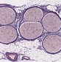

NOTES

FEEDBACK

**Classification of nerve fibers**

Nerve fibers are classified based on their conduction velocity, diameter, and [axon](https://next.amboss.com/us/article/lp0vpS#Z7a7039b9bbc6353245e697e51712c2c4) characteristics.

MAXIMIZE TABLETABLE QUIZ

| **Classification of nerve fibers** | | | | | |
| --- | --- | --- | --- | --- | --- |
| **Nerve fibers** | **Myelinated** | **Characteristics** | **Conduction velocity** | **Size** |
| **A-alpha fibers** | * Yes | * Afferent: [muscle spindles](https://next.amboss.com/us/article/G60BmS" \l "Zd4190ac23311f6332b702f5b78c5e3c0) * Efferent: [alpha motor neurons](https://next.amboss.com/us/article/G60BmS" \l "Zcc61bf4b3ccd8b2cff7f6e5a657563f1) | * 60–120 m/s | * 15 μm |
| **A-beta fibers** | * Afferent: cutaneous mechanoreceptors | * 30–60 m/s | * 8 μm |
| **A-gamma fibers** | * Efferent: [muscle spindles](https://next.amboss.com/us/article/G60BmS#Zd4190ac23311f6332b702f5b78c5e3c0) (gamma motoneurons) | * 2–30 m/s | * 5 μm |
| **A-delta fibers** | * Afferent: [pain](https://next.amboss.com/us/article/xN0EWg#Zd673a3f7ee36023aab5a267899e984cc) (e.g., thermal, mechanical )   + Free nerve endings   + Responsible for the withdrawal response to [pain](https://next.amboss.com/us/article/xN0EWg#Zd673a3f7ee36023aab5a267899e984cc) (e.g., rapidly moving the hand when burned) | * 3 μm |
| **B fibers** | * Moderately | * Efferent: [preganglionic](https://next.amboss.com/us/article/560ilS" \l "Z754537075c5105c55477db49c94d584f) [sympathetic](https://next.amboss.com/us/article/560ilS" \l "Ze80abab5d42f0490f5ab74735e7e76da) fibers | * 3–15 m/s | * < 3 μm |
| **C fibers** | * No (lack of [myelin](https://next.amboss.com/us/article/lp0vpS#Z5c8a0a205a24fdf1ccd326f18250fbe1) creates the slow conduction as the [saltatory conduction](https://next.amboss.com/us/article/9o0NVS#Z65abd3610cc08ab0b403e3dc4daad1bb) is not present) | * Afferent: [pain](https://next.amboss.com/us/article/xN0EWg#Zd673a3f7ee36023aab5a267899e984cc) (e.g., chemical, thermal, mechanical) | * 0.25–1.5 m/s | * 1 μm |

[C fibers](https://next.amboss.com/us/article/lp0vpS#Z4fe6ed7cbe0e14b8eed085c372a0a151) have a slow conduction velocity due to their small diameter and lack of myelination.

NOTES

FEEDBACK

**Neurotransmitters**

[**Neurotransmitters**](https://next.amboss.com/us/article/lp0vpS#Z52019f1f39ac49ccfe9ec7e865d1766d)

[Neurotransmitters](https://next.amboss.com/us/article/lp0vpS#Z52019f1f39ac49ccfe9ec7e865d1766d) are endogenous substances that allow communication between [neurons](https://next.amboss.com/us/article/lp0vpS#Zeb508d67af399f2b2da18e8b2cc5eed8) and, usually, induce a change in the [target cell](https://next.amboss.com/us/article/WS0PA2#Zcc652cbd7322c252dc18d5d510740f9e). There are two types of [neurotransmitters](https://next.amboss.com/us/article/lp0vpS" \l "Z52019f1f39ac49ccfe9ec7e865d1766d):

* **Conventional**[**neurotransmitters**](https://next.amboss.com/us/article/lp0vpS#Z52019f1f39ac49ccfe9ec7e865d1766d): molecules that follow conventional [synaptic transmission](https://next.amboss.com/us/article/lp0vpS#Z1bfc0864fad66774968660d4edf6f55a) (see [chemical synapse](https://next.amboss.com/us/article/lp0vpS#Zedc2c888b2ab609e25b5a76884d52325) below)
  + Small molecule [neurotransmitters](https://next.amboss.com/us/article/lp0vpS#Z52019f1f39ac49ccfe9ec7e865d1766d): [GABA](https://next.amboss.com/us/article/lp0vpS#Z6625804b83e4ca0c92651a2763692086), [dopamine](https://next.amboss.com/us/article/tN0X1g#Z0db70cd20a4945b51725d7adce664557), [norepinephrine](https://next.amboss.com/us/article/lp0vpS#Z3c0eaeb56003161b0a4d01de1c8dcdc9), [epinephrine](https://next.amboss.com/us/article/tN0X1g#Ze19a3a687d52dabea192f2d65d127a47), [serotonin](https://next.amboss.com/us/article/lp0vpS#Z66351ff66c1492921628337667462b5a), [histamine](https://next.amboss.com/us/article/ek0x5T#Zae1b7b5f59d06769c8445ee3e4389b73), [ATP](https://next.amboss.com/us/article/L60wlS#Z4f7fa4d9569b38d1dc67b96262f66332), [glutamate](https://next.amboss.com/us/article/lp0vpS#Z0555ea6b157157d3843b24e686403f7f), [aspartate](https://next.amboss.com/us/article/FK0gRS#Z110aa32714335391cccf9a0d0dde5d11), adenosine, and [acetylcholine](https://next.amboss.com/us/article/lp0vpS#Z3c3ab1c3772cabdb26be3c413ba52df4)
  + Neuropeptides: [endorphins](https://next.amboss.com/us/article/lp0vpS#Z2c50b671aa4c93ccbb3a23aea4f079f3), [enkephalins](https://next.amboss.com/us/article/lp0vpS#Z7fdda21922da2cc81ab397e6a4cd60b2), substance P, and [neuropeptide Y](https://next.amboss.com/us/article/AT0Rt2#Z9b13fabfa703d2eab40fea4538546076)
* **Unconventional**[**neurotransmitters**](https://next.amboss.com/us/article/lp0vpS#Z52019f1f39ac49ccfe9ec7e865d1766d): molecules that are not stored in [synaptic](https://next.amboss.com/us/article/lp0vpS#Zdcd1055abed8e01dc833605f76cb61ae) vesicles, may carry messages from the postsynaptic to the presynaptic [neuron](https://next.amboss.com/us/article/lp0vpS#Zeb508d67af399f2b2da18e8b2cc5eed8) and can cross [the cell](https://next.amboss.com/us/article/Lo0wcS#Z0b2dbba84cd425084862e30873efee1a) membrane, acting directly on molecules inside the cells.
  + [Endocannabinoids](https://next.amboss.com/us/article/AT0Rt2#Zf4d714232bb55c131a75e9edaf0ce8de)
  + Gasotransmitters: [nitric oxide](https://next.amboss.com/us/article/qo0C1S#Z6e41007f5cfe26f595a9a8859b96a31c) and carbon monoxide

MAXIMIZE TABLETABLE QUIZ

| **Overview of [neurotransmitters](https://next.amboss.com/us/article/lp0vpS" \l "Z52019f1f39ac49ccfe9ec7e865d1766d)** | | |
| --- | --- | --- |
| [**Neurotransmitter**](https://next.amboss.com/us/article/lp0vpS#Z52019f1f39ac49ccfe9ec7e865d1766d) | **Site of action** | **Characteristics** |
| **Acetylcholine** | * [**Preganglionic**](https://next.amboss.com/us/article/560ilS#Z754537075c5105c55477db49c94d584f)**[sympathetic](https://next.amboss.com/us/article/560ilS" \l "Ze80abab5d42f0490f5ab74735e7e76da) [synapses](https://next.amboss.com/us/article/lp0vpS" \l "Zdcd1055abed8e01dc833605f76cb61ae)** * [Neuromuscular junction](https://next.amboss.com/us/article/lp0vpS#Z3c15ed824470b5b7ec72fc4c39ee3075) * [Parasympathetic](https://next.amboss.com/us/article/560ilS#Za4884432bfd8263f7f79f9b0cb0af287) [synapses](https://next.amboss.com/us/article/lp0vpS" \l "Zdcd1055abed8e01dc833605f76cb61ae) | * Usually excitatory * Synthesized from choline and [acetyl coenzyme A](https://next.amboss.com/us/article/o600NS#Z3779a40335abfe5e962768bb0d21ea36). * Two [receptors](https://next.amboss.com/us/article/qo0C1S" \l "Z3ff0122a3c004eebed96e9db47e16ea4)   + Nicotinic AChR   + Muscarinic AChR |
| [**Aspartate**](https://next.amboss.com/us/article/FK0gRS#Z110aa32714335391cccf9a0d0dde5d11) | * [CNS](https://next.amboss.com/us/article/lp0vpS#Z0111aade770ed6f7d136b455de1d6c1f) | * Excitatory |
| [**Dopamine**](https://next.amboss.com/us/article/tN0X1g#Z0db70cd20a4945b51725d7adce664557) | * [CNS](https://next.amboss.com/us/article/lp0vpS#Z0111aade770ed6f7d136b455de1d6c1f) * Local chemical messenger in other organ systems (e.g., increases [natriuresis](https://next.amboss.com/us/article/gm0FUg#Z7fd00610a343bd3852e3aa64bea203b4) in the [kidney](https://next.amboss.com/us/article/m60VlS#Z517d2cc21845787cbf2c6ff27c21cd8e)) | * Both excitatory and inhibitory * Involved in initiation of movement * Inhibits the secretion of [prolactin](https://next.amboss.com/us/article/AT0Rt2#Z3fe3125b96d1930c55dbc47c2c31910b) by the [anterior pituitary](https://next.amboss.com/us/article/AT0Rt2#Z95d7dfaca1d7a11cc94dbc9884126e3f) upon release by the [hypothalamus](https://next.amboss.com/us/article/-60DnS#Z90567581e440893e2c4839a28332f0cf) |
| **Endorphins** | * [CNS](https://next.amboss.com/us/article/lp0vpS#Z0111aade770ed6f7d136b455de1d6c1f) | * Endogenous [opioids](https://next.amboss.com/us/article/yN0ddg#Z434daecbc44532c03b0313928f0c321d) produced by the [CNS](https://next.amboss.com/us/article/lp0vpS#Z0111aade770ed6f7d136b455de1d6c1f) and [pituitary gland](https://next.amboss.com/us/article/AT0Rt2#Zf261fc5b32a905f3dde728d2f04a4b7a) * Inhibit [pain](https://next.amboss.com/us/article/xN0EWg" \l "Zd673a3f7ee36023aab5a267899e984cc) |
| **Enkephalins** | * Inhibit [pain](https://next.amboss.com/us/article/xN0EWg" \l "Zd673a3f7ee36023aab5a267899e984cc) |
| **GABA** | * Inhibitory * Is mainly synthesized from [glutamate](https://next.amboss.com/us/article/lp0vpS#Z0555ea6b157157d3843b24e686403f7f) via the enzyme glutamate decarboxylase |
| **Glutamate** | * Two types   + Ionotropic glutamate receptors ([iGluR](https://next.amboss.com/us/article/lp0vpS" \l "Z5484a008c5e28f82d94e147acac449db))     - Excitatory [glutamate](https://next.amboss.com/us/article/lp0vpS" \l "Z0555ea6b157157d3843b24e686403f7f)-gated ion channels     - Three subtypes:       * N-methyl-D-aspartate receptor (NMDA-R)       * Quisqualate receptor (AMPA-R)       * Kainate [receptors](https://next.amboss.com/us/article/qo0C1S" \l "Z3ff0122a3c004eebed96e9db47e16ea4)   + Metabotropic glutamate receptors (mGluR): excitatory or inhibitory [G-protein](https://next.amboss.com/us/article/qo0C1S#Zce7f8529256e6ba2e2a9eba788c01703) coupled [receptors](https://next.amboss.com/us/article/qo0C1S#Z3ff0122a3c004eebed96e9db47e16ea4) * Involved in long-term potentiation (e.g., learning, addiction) and neuronal excitotoxicity |
| **Glycine** | * **Spinal cord** * [Brainstem](https://next.amboss.com/us/article/b70H4h#Z147ea0a4bbdff4d78bc40bde59d23bed) * [Retina](https://next.amboss.com/us/article/cp0aoS#Zafbc538c70facdb76c5c65393ad05dbb) | * Inhibitory |
| **Norepinephrine** | * [**Postganglionic**](https://next.amboss.com/us/article/560ilS#Z085c20d6acaac770f3a6c0854e10069c)**[sympathetic](https://next.amboss.com/us/article/560ilS" \l "Ze80abab5d42f0490f5ab74735e7e76da) [synapses](https://next.amboss.com/us/article/lp0vpS" \l "Zdcd1055abed8e01dc833605f76cb61ae)** * [CNS](https://next.amboss.com/us/article/lp0vpS#Z0111aade770ed6f7d136b455de1d6c1f) | * [Neurotransmitter](https://next.amboss.com/us/article/lp0vpS#Z52019f1f39ac49ccfe9ec7e865d1766d) and [hormone](https://next.amboss.com/us/article/AT0Rt2" \l "Zc880c21d5265a921cfdf80b444377952) |
| [**Epinephrine**](https://next.amboss.com/us/article/tN0X1g#Ze19a3a687d52dabea192f2d65d127a47) | * [CNS](https://next.amboss.com/us/article/lp0vpS#Z0111aade770ed6f7d136b455de1d6c1f) |
| **Serotonin** | * [CNS](https://next.amboss.com/us/article/lp0vpS#Z0111aade770ed6f7d136b455de1d6c1f) | * Involved in sleep, mood, and [pain](https://next.amboss.com/us/article/xN0EWg#Zd673a3f7ee36023aab5a267899e984cc) inhibition * Inhibitory |

**Neurotransmitter receptors ([neuroreceptors](https://next.amboss.com/us/article/lp0vpS" \l "Zc60093e07246ae069dd43c0090420519))**

* **Definition**: a [membrane receptor](https://next.amboss.com/us/article/qo0C1S#Z9c80774c32ba7aa9d47c2a5e5d896e28) protein that is activated by a [neurotransmitter](https://next.amboss.com/us/article/lp0vpS#Z52019f1f39ac49ccfe9ec7e865d1766d)
* **Characteristics**
  + Membrane-bound, activated by the binding of [neurotransmitters](https://next.amboss.com/us/article/lp0vpS#Z52019f1f39ac49ccfe9ec7e865d1766d)
  + Found on presynaptic and postsynaptic neuronal membranes
  + Open or close ion channels, producing electrical signals
  + Excitatory and inhibitory responses are determined by the class of ion channel and by the concentration of permeant ions inside and outside [the cell](https://next.amboss.com/us/article/Lo0wcS#Z0b2dbba84cd425084862e30873efee1a).
* **Types of [receptors](https://next.amboss.com/us/article/qo0C1S" \l "Z3ff0122a3c004eebed96e9db47e16ea4)**
  + [Ionotropic receptors](https://next.amboss.com/us/article/qo0C1S#Zeaa81702d59cd45f8d10062010b96f21) ([ligand-gated ion channels](https://next.amboss.com/us/article/qo0C1S#Zeaa81702d59cd45f8d10062010b96f21)): form channels through which ions, e.g., Na+ and [Ca2+](https://next.amboss.com/us/article/Hg0K92#Z96f09f8b59b6467bac2f983358a263bb), flow
  + [Metabotropic ion receptors](https://next.amboss.com/us/article/lp0vpS#Z350a7a9d2b4db689dfc1671b806e8cff) ([G-protein](https://next.amboss.com/us/article/qo0C1S#Zce7f8529256e6ba2e2a9eba788c01703) coupled [receptors](https://next.amboss.com/us/article/qo0C1S#Z3ff0122a3c004eebed96e9db47e16ea4)): are coupled to intracellular [G proteins](https://next.amboss.com/us/article/qo0C1S#Zce7f8529256e6ba2e2a9eba788c01703) that are activated upon binding to a [ligand](https://next.amboss.com/us/article/qo0C1S#Z77cbbfdd8009c0c0d1de2aa4b04a1062)
  + Other: presynaptic [receptors](https://next.amboss.com/us/article/qo0C1S" \l "Z3ff0122a3c004eebed96e9db47e16ea4) (autoreceptors)
    - Respond to the transmitter released by the same [neuron](https://next.amboss.com/us/article/lp0vpS#Zeb508d67af399f2b2da18e8b2cc5eed8)
    - Regulate [neurotransmitter release](https://next.amboss.com/us/article/lp0vpS#Z044841fc26b094fc4469f69dbd92f79e), synthesis, or impulse flow
    - Considered a homeostatic feedback mechanism

MAXIMIZE TABLETABLE QUIZ

| **Overview of [neurotransmitter receptors](https://next.amboss.com/us/article/lp0vpS" \l "Zc60093e07246ae069dd43c0090420519) [6]** | | |
| --- | --- | --- |
|  | **Ionotropic receptors** | **Metabotropic receptors** |
| **Characteristics** | * Allosteric binding site * The [receptor](https://next.amboss.com/us/article/qo0C1S#Z3ff0122a3c004eebed96e9db47e16ea4) molecule is also an ion channel (channel-linked). | * [Signal transduction](https://next.amboss.com/us/article/qo0C1S#Z120b3d64e4c26c0c457ea26dcc34727c) mechanisms, usually [G-proteins](https://next.amboss.com/us/article/qo0C1S#Zce7f8529256e6ba2e2a9eba788c01703), to activate intracellular events using a [second messenger](https://next.amboss.com/us/article/qo0C1S#Z1972306683781159a08cb00460690339) * The [receptor](https://next.amboss.com/us/article/qo0C1S#Z3ff0122a3c004eebed96e9db47e16ea4) and ion channel are separate molecules. |
| [**Receptor**](https://next.amboss.com/us/article/qo0C1S#Z3ff0122a3c004eebed96e9db47e16ea4)**opening time** | * Fast | * Slow |
| **Response** | * Short-lasting postsynaptic potentials (PSPs) or fast PSPs | * Long-lasting postsynaptic or slow PSPs |
| **Target effect location** | * Within the immediate region of the [receptor](https://next.amboss.com/us/article/qo0C1S#Z3ff0122a3c004eebed96e9db47e16ea4) | * Effects can be more widespread and persistent throughout [the cell](https://next.amboss.com/us/article/Lo0wcS#Z0b2dbba84cd425084862e30873efee1a) |
| [**Receptor**](https://next.amboss.com/us/article/qo0C1S#Z3ff0122a3c004eebed96e9db47e16ea4)**examples** | * **Nicotinic [acetylcholine](https://next.amboss.com/us/article/lp0vpS" \l "Z3c3ab1c3772cabdb26be3c413ba52df4)** * GABAA * 5-HT3 receptor * [Glycine](https://next.amboss.com/us/article/lp0vpS#Z9d413135595c08ee0b3623a597d55dbf) * [Glutamate](https://next.amboss.com/us/article/lp0vpS#Z0555ea6b157157d3843b24e686403f7f) | * [**Glutamate**](https://next.amboss.com/us/article/lp0vpS#Z0555ea6b157157d3843b24e686403f7f) * Muscarinic [acetylcholine](https://next.amboss.com/us/article/lp0vpS" \l "Z3c3ab1c3772cabdb26be3c413ba52df4) * GABAB * α and β [norepinephrine](https://next.amboss.com/us/article/lp0vpS#Z3c0eaeb56003161b0a4d01de1c8dcdc9) and [epinephrine](https://next.amboss.com/us/article/tN0X1g#Ze19a3a687d52dabea192f2d65d127a47) [receptors](https://next.amboss.com/us/article/qo0C1S#Z3ff0122a3c004eebed96e9db47e16ea4) * [Histamine](https://next.amboss.com/us/article/ek0x5T#Zae1b7b5f59d06769c8445ee3e4389b73) * [Dopamine](https://next.amboss.com/us/article/tN0X1g#Z0db70cd20a4945b51725d7adce664557) * Neuropeptides |

**Ion channels [6]**

* **Definition**: [transmembrane proteins](https://next.amboss.com/us/article/Lo0wcS#Z791e663c03e28aa459a29279a8854bee) with a narrow pore that selectively permits particular ions to permeate the membrane
* **Functions**
  + Give rise to selective ion permeability changes
  + Detect the electrical potential across the membrane
  + Involved in changing of local transmembrane potentials
* **Types of channels**
  + Voltage-gated ion channels: selectively permeable to the major physiological ions (K+, Na+, [Ca2+](https://next.amboss.com/us/article/Hg0K92#Z96f09f8b59b6467bac2f983358a263bb), Cl-), responding to changes in membrane potential (e.g., [depolarization](https://next.amboss.com/us/article/9o0NVS#Zd4e0a1caa2f5d32a12799b9d4209249e), [hyperpolarization](https://next.amboss.com/us/article/9o0NVS#Z132a0858f7c564d83fd42ca92fb1c9ba)); e.g., Na+and [Ca2+](https://next.amboss.com/us/article/Hg0K92#Z96f09f8b59b6467bac2f983358a263bb) channels
  + [Ligand-gated ion channels](https://next.amboss.com/us/article/qo0C1S#Zeaa81702d59cd45f8d10062010b96f21): cell-surface ion channels that increase ion flux in response to [ligand](https://next.amboss.com/us/article/qo0C1S#Z77cbbfdd8009c0c0d1de2aa4b04a1062) or drug binding to, e.g., [G-protein](https://next.amboss.com/us/article/qo0C1S#Zce7f8529256e6ba2e2a9eba788c01703)-gated [neurotransmitter receptors](https://next.amboss.com/us/article/lp0vpS#Zc60093e07246ae069dd43c0090420519)
  + Mechanically-gated ion channels: transmembrane ion channels that are activated by changes in the structure of the membrane and allow the passage of ions when open. [Mechanically-gated ion channels](https://next.amboss.com/us/article/lp0vpS#Zbde5ec1c03a200a7041d22802f6e7c4f) are generally specific to one of the major physiological ions (K+, Na+, [Ca2+](https://next.amboss.com/us/article/Hg0K92#Z96f09f8b59b6467bac2f983358a263bb), Cl-).

**Clinical significance of neurotransmitter changes**

MAXIMIZE TABLETABLE QUIZ

| **Overview of the**[**clinical significance of neurotransmitter changes**](https://next.amboss.com/us/article/lp0vpS#Z7ad2cbc1443489b9d33aaa1275d65a61) | | | |
| --- | --- | --- | --- |
| [**Neurotransmitter**](https://next.amboss.com/us/article/lp0vpS#Z52019f1f39ac49ccfe9ec7e865d1766d) | **Site of action** | **Associated conditions** | |
| **Increased levels** | **Decreased levels** |
| [**Acetylcholine**](https://next.amboss.com/us/article/lp0vpS#Z3c3ab1c3772cabdb26be3c413ba52df4) | * Basal nucleus of Meynert (forebrain) * [Neuromuscular junction](https://next.amboss.com/us/article/lp0vpS#Z3c15ed824470b5b7ec72fc4c39ee3075) | * [Parkinson disease](https://next.amboss.com/us/article/C30qkf#Zab69cf8e484a0b848765347ea6dc1cd7) | * [Alzheimer disease](https://next.amboss.com/us/article/D301kf#Z871d1bb7a791c1b1b4a1351d40ed3cd0) * [Huntington disease](https://next.amboss.com/us/article/y30dOf#Zdb95de20a58de3304969375da7c97978) |
| [**Dopamine**](https://next.amboss.com/us/article/tN0X1g#Z0db70cd20a4945b51725d7adce664557) | * [Substantia nigra](https://next.amboss.com/us/article/b70H4h#Zf2fb6ce12d82eaa3f2ea7f2f0faa873a), mainly pars compacta ([midbrain](https://next.amboss.com/us/article/b70H4h#Z61459b89d8275179f2613bf5a34ce980)) * [Ventral](https://next.amboss.com/us/article/xo0EVS#Zb18ada80aa42846bdf8d3785e2480ff1) tegmental area ([midbrain](https://next.amboss.com/us/article/b70H4h" \l "Z61459b89d8275179f2613bf5a34ce980)) | * [Schizophrenia](https://next.amboss.com/us/article/pP0LfT#Z2988495da67e41c0dfbd5c9a150e3442) * [Huntington disease](https://next.amboss.com/us/article/y30dOf#Zdb95de20a58de3304969375da7c97978) | * Depression * [Parkinson disease](https://next.amboss.com/us/article/C30qkf#Zab69cf8e484a0b848765347ea6dc1cd7) |
| [**Norepinephrine**](https://next.amboss.com/us/article/lp0vpS#Z3c0eaeb56003161b0a4d01de1c8dcdc9) | * [Locus coeruleus](https://next.amboss.com/us/article/b70H4h#Z5e757724ffd6d28e8e3a3e32b2f3868c) ([pons](https://next.amboss.com/us/article/b70H4h" \l "Z88fca2df1d4871d74fd84e4dfea2be96)) | * [Anxiety](https://next.amboss.com/us/article/kP0mUT#Z6ed492871b68b31189bcb84adbfe1e96) | * Depression |
| [**Serotonin**](https://next.amboss.com/us/article/lp0vpS#Z66351ff66c1492921628337667462b5a) | * Raphe nucleus (medulla, [pons](https://next.amboss.com/us/article/b70H4h" \l "Z88fca2df1d4871d74fd84e4dfea2be96)) | * [Serotonin syndrome](https://next.amboss.com/us/article/ZF0Zg3#Z23b9a5a4f51f7b6d1e265fc9e2c158d9) | * [Anxiety](https://next.amboss.com/us/article/kP0mUT#Z6ed492871b68b31189bcb84adbfe1e96) * Depression: some [antidepressants](https://next.amboss.com/us/article/_N05dg#Zbce15ff7dae8faec7f3de858ace84bdb) act by increasing [synaptic](https://next.amboss.com/us/article/lp0vpS#Zdcd1055abed8e01dc833605f76cb61ae) [serotonin](https://next.amboss.com/us/article/lp0vpS#Z66351ff66c1492921628337667462b5a) by selectively inhibiting [serotonin](https://next.amboss.com/us/article/lp0vpS#Z66351ff66c1492921628337667462b5a) reuptake ([SSRIs](https://next.amboss.com/us/article/_N05dg#Zb1bb43280a4d0d86f2d53818b9e8afc8); e.g., [escitalopram](https://next.amboss.com/us/article/_N05dg#Z1dfb430bcc30f2c9700b00ed0737cc31)) * [Parkinson disease](https://next.amboss.com/us/article/C30qkf#Zab69cf8e484a0b848765347ea6dc1cd7) [7] |
| [**GABA**](https://next.amboss.com/us/article/lp0vpS#Z6625804b83e4ca0c92651a2763692086) | * [Nucleus accumbens](https://next.amboss.com/us/article/WK0P2S#Z2c58d4724efe17135a063eb38bbb2ab1) ([basal ganglia](https://next.amboss.com/us/article/WK0P2S" \l "Z2eb2f30c001f2b5fa17eeba767aa7b39)) | * N/A | * [Anxiety](https://next.amboss.com/us/article/kP0mUT#Z6ed492871b68b31189bcb84adbfe1e96) * [Huntington disease](https://next.amboss.com/us/article/y30dOf#Zdb95de20a58de3304969375da7c97978) |

NOTES

FEEDBACK

**Synapses**

**Definitions**

* **Synapses**: the junction across which signals or [action potentials](https://next.amboss.com/us/article/9o0NVS#Z0988f6842348a3c63311140c08a28497) are transmitted from a presynaptic to a postsynaptic structure (e.g., [neurons](https://next.amboss.com/us/article/lp0vpS#Zeb508d67af399f2b2da18e8b2cc5eed8), muscle).
* **Synaptic transmission**: the process of communication between two [neurons](https://next.amboss.com/us/article/lp0vpS#Zeb508d67af399f2b2da18e8b2cc5eed8), involving the release of a [neurotransmitter](https://next.amboss.com/us/article/lp0vpS#Z52019f1f39ac49ccfe9ec7e865d1766d) by the presynaptic [neuron](https://next.amboss.com/us/article/lp0vpS#Zeb508d67af399f2b2da18e8b2cc5eed8) and the [neurotransmitter](https://next.amboss.com/us/article/lp0vpS#Z52019f1f39ac49ccfe9ec7e865d1766d) binding to [receptors](https://next.amboss.com/us/article/qo0C1S#Z3ff0122a3c004eebed96e9db47e16ea4) on the postsynaptic membrane
* **Fast neurotransmission**: direct activation of a [ligand-gated ion channel](https://next.amboss.com/us/article/qo0C1S#Zeaa81702d59cd45f8d10062010b96f21) by a [neurotransmitter](https://next.amboss.com/us/article/lp0vpS#Z52019f1f39ac49ccfe9ec7e865d1766d)
* **Neuromodulation**: occurs when a [neurotransmitter](https://next.amboss.com/us/article/lp0vpS#Z52019f1f39ac49ccfe9ec7e865d1766d) binds to a [G-protein](https://next.amboss.com/us/article/qo0C1S#Zce7f8529256e6ba2e2a9eba788c01703)-bound [receptor](https://next.amboss.com/us/article/qo0C1S#Z3ff0122a3c004eebed96e9db47e16ea4) and activates a chemical [signaling cascade](https://next.amboss.com/us/article/qo0C1S#Z48c72a18f56e02deeab699caf23aa2cc)

**General**

* There are two types of [synapses](https://next.amboss.com/us/article/lp0vpS#Zdcd1055abed8e01dc833605f76cb61ae): chemical and electrical
* [Synapses](https://next.amboss.com/us/article/lp0vpS#Zdcd1055abed8e01dc833605f76cb61ae) can further be classified according to the structures between which they signal:
  + Axodendritic [synapses](https://next.amboss.com/us/article/lp0vpS#Zdcd1055abed8e01dc833605f76cb61ae): signal between [axons](https://next.amboss.com/us/article/lp0vpS#Z7a7039b9bbc6353245e697e51712c2c4) and [dendrites](https://next.amboss.com/us/article/lp0vpS#Z3e8773a5d2f360213b09c01c950245f3)
  + Axoaxonic [synapses](https://next.amboss.com/us/article/lp0vpS" \l "Zdcd1055abed8e01dc833605f76cb61ae): signal between [axons](https://next.amboss.com/us/article/lp0vpS" \l "Z7a7039b9bbc6353245e697e51712c2c4)
  + Axosomatic [synapses](https://next.amboss.com/us/article/lp0vpS#Zdcd1055abed8e01dc833605f76cb61ae): signal between [axons](https://next.amboss.com/us/article/lp0vpS#Z7a7039b9bbc6353245e697e51712c2c4) and [the cell](https://next.amboss.com/us/article/Lo0wcS#Z0b2dbba84cd425084862e30873efee1a) body of [neurons](https://next.amboss.com/us/article/lp0vpS#Zeb508d67af399f2b2da18e8b2cc5eed8)
  + Dendrodendritic [synapses](https://next.amboss.com/us/article/lp0vpS" \l "Zdcd1055abed8e01dc833605f76cb61ae): signal between [dendrites](https://next.amboss.com/us/article/lp0vpS" \l "Z3e8773a5d2f360213b09c01c950245f3)

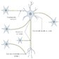

**Chemical synapses**

A type of [synapse](https://next.amboss.com/us/article/lp0vpS#Zdcd1055abed8e01dc833605f76cb61ae) that transmits signals between [neurons](https://next.amboss.com/us/article/lp0vpS#Zeb508d67af399f2b2da18e8b2cc5eed8) separated by a cleft via a chemical [neurotransmitter](https://next.amboss.com/us/article/lp0vpS#Z52019f1f39ac49ccfe9ec7e865d1766d)

**Overview**

* Composed of a presynaptic membrane, a synaptic cleft (the space between a presynaptic and postsynaptic [neuron](https://next.amboss.com/us/article/lp0vpS#Zeb508d67af399f2b2da18e8b2cc5eed8)), and postsynaptic membrane
* Most [neurotransmitters](https://next.amboss.com/us/article/lp0vpS#Z52019f1f39ac49ccfe9ec7e865d1766d) (e.g., [GABA](https://next.amboss.com/us/article/lp0vpS#Z6625804b83e4ca0c92651a2763692086), [glutamate](https://next.amboss.com/us/article/lp0vpS#Z0555ea6b157157d3843b24e686403f7f), [glycine](https://next.amboss.com/us/article/lp0vpS#Z9d413135595c08ee0b3623a597d55dbf)) undergo the following steps: **synthesis, storage, release, reuptake, and degradation**

**Mechanism (presynaptic and postsynaptic receptor interactions)**

1. **Neurotransmitter synthesis**
   * Occurs in the presynaptic [neuron](https://next.amboss.com/us/article/lp0vpS" \l "Zeb508d67af399f2b2da18e8b2cc5eed8)
   * A precursor [amino acid](https://next.amboss.com/us/article/FK0gRS#Z0438599f04071c0cbe4805dd1ad4b9f7) accumulates into the [neuron](https://next.amboss.com/us/article/lp0vpS#Zeb508d67af399f2b2da18e8b2cc5eed8).
   * The precursor is metabolized sequentially and yields a mature transmitter.
2. **Neurotransmitter storage**
   * Vesicles filled with [neurotransmitters](https://next.amboss.com/us/article/lp0vpS#Z52019f1f39ac49ccfe9ec7e865d1766d) are stored in the presynaptic terminal and to be released in response to stimulation of the [neuron](https://next.amboss.com/us/article/lp0vpS#Zeb508d67af399f2b2da18e8b2cc5eed8)
   * **Synaptophysin** is a major [synaptic](https://next.amboss.com/us/article/lp0vpS#Zdcd1055abed8e01dc833605f76cb61ae) [vesicle](https://next.amboss.com/us/article/_405NT#Z7c5fd3823051fa560edec27fe227985f) protein that is thought to play a role in [synaptic](https://next.amboss.com/us/article/lp0vpS#Zdcd1055abed8e01dc833605f76cb61ae) [vesicle](https://next.amboss.com/us/article/_405NT#Z7c5fd3823051fa560edec27fe227985f) formation and maintenance [8]
     + Expressed throughout the brain
     + Used as a marker for neuronal cells as well as neuroendocrine tumors
3. **Neurotransmitter release**
   * [Action potentials](https://next.amboss.com/us/article/9o0NVS#Z0988f6842348a3c63311140c08a28497) in the presynaptic cell trigger the opening of voltage-gated [Ca2+](https://next.amboss.com/us/article/Hg0K92#Z96f09f8b59b6467bac2f983358a263bb) channels in the presynaptic membrane, permitting [Ca2+](https://next.amboss.com/us/article/Hg0K92#Z96f09f8b59b6467bac2f983358a263bb) influx.
   * [Ca2+](https://next.amboss.com/us/article/Hg0K92#Z96f09f8b59b6467bac2f983358a263bb) binds to synaptotagmin (a protein anchored in the [vesicle](https://next.amboss.com/us/article/_405NT#Z7c5fd3823051fa560edec27fe227985f) membrane), which initiates the [vesicle](https://next.amboss.com/us/article/_405NT#Z7c5fd3823051fa560edec27fe227985f) docking to the presynaptic membrane and formation of [SNARE complex](https://next.amboss.com/us/article/lp0vpS#Zeaa09a4562fd5dc1b1beb63b4676b388). [9]
   * **SNARE complex**
     + Stands for **S**oluble **N**SF **A**ttachment protein **RE**ceptor complex
     + Consists of several [SNARE proteins](https://next.amboss.com/us/article/lp0vpS#Zeaa09a4562fd5dc1b1beb63b4676b388), which are attached to either:
       - The [vesicle](https://next.amboss.com/us/article/_405NT#Z7c5fd3823051fa560edec27fe227985f) membrane (v-[SNARE](https://next.amboss.com/us/article/lp0vpS#Zeaa09a4562fd5dc1b1beb63b4676b388) [proteins](https://next.amboss.com/us/article/8K0ORS#Z6dee07cab92e13d1f6baa3a3ce402f23); e.g., synaptobrevin)
       - The presynaptic target membrane (t-[SNARE](https://next.amboss.com/us/article/lp0vpS#Zeaa09a4562fd5dc1b1beb63b4676b388) [proteins](https://next.amboss.com/us/article/8K0ORS#Z6dee07cab92e13d1f6baa3a3ce402f23);  e.g., syntaxin 1, SNAP 25 )
       - v-[SNARE](https://next.amboss.com/us/article/lp0vpS#Zeaa09a4562fd5dc1b1beb63b4676b388) and t-[SNARE](https://next.amboss.com/us/article/lp0vpS#Zeaa09a4562fd5dc1b1beb63b4676b388) [proteins](https://next.amboss.com/us/article/8K0ORS#Z6dee07cab92e13d1f6baa3a3ce402f23) combine at the presynaptic membrane to form the [SNARE complex](https://next.amboss.com/us/article/lp0vpS#Zeaa09a4562fd5dc1b1beb63b4676b388).
   * During [SNARE complex](https://next.amboss.com/us/article/lp0vpS#Zeaa09a4562fd5dc1b1beb63b4676b388) formation, the [vesicle](https://next.amboss.com/us/article/_405NT#Z7c5fd3823051fa560edec27fe227985f) membrane and the presynaptic membrane merge, causing [neurotransmitters](https://next.amboss.com/us/article/lp0vpS#Z52019f1f39ac49ccfe9ec7e865d1766d) to be released into the [synaptic cleft](https://next.amboss.com/us/article/lp0vpS#Z8fa6a37913ebcbc5593b41d7563ac73d).
4. **Neurotransmitter binding and recognition by target**[**receptors**](https://next.amboss.com/us/article/qo0C1S#Z3ff0122a3c004eebed96e9db47e16ea4)
   * [Neurotransmitters](https://next.amboss.com/us/article/lp0vpS#Z52019f1f39ac49ccfe9ec7e865d1766d) act on [receptors](https://next.amboss.com/us/article/qo0C1S#Z3ff0122a3c004eebed96e9db47e16ea4) on the postsynaptic membrane, resulting in the influx of ions into the postsynaptic cell.
   * An [action potential](https://next.amboss.com/us/article/9o0NVS#Z0988f6842348a3c63311140c08a28497) is created on the postsynaptic cell, completing the passage of the [neurotransmitter](https://next.amboss.com/us/article/lp0vpS#Z52019f1f39ac49ccfe9ec7e865d1766d) from the presynaptic to the postsynaptic cell.
5. **Termination of the action of the released transmitter**
   * [Neurotransmitter](https://next.amboss.com/us/article/lp0vpS#Z52019f1f39ac49ccfe9ec7e865d1766d) actions may be terminated by the following three interlinked processes.
     + Neurotransmitter reuptake: an active termination process triggered by specific transporter [proteins](https://next.amboss.com/us/article/8K0ORS#Z6dee07cab92e13d1f6baa3a3ce402f23) on the presynaptic [neuron](https://next.amboss.com/us/article/lp0vpS#Zeb508d67af399f2b2da18e8b2cc5eed8) or on [glial cells](https://next.amboss.com/us/article/lp0vpS#Z0141b87aed6e35dbc01acec20bfa41a8) where the [neurotransmitter](https://next.amboss.com/us/article/lp0vpS#Z52019f1f39ac49ccfe9ec7e865d1766d) is stored
     + Neurotransmitter enzymatic degradation: a termination process triggered by enzymes in the [synaptic cleft](https://next.amboss.com/us/article/lp0vpS#Z8fa6a37913ebcbc5593b41d7563ac73d) (e.g., acetylcholinesterase) yielding an inactive substance
     + Neurotransmitter diffusion: a dispersal of the [neurotransmitter](https://next.amboss.com/us/article/lp0vpS#Z52019f1f39ac49ccfe9ec7e865d1766d) out of the [synaptic cleft](https://next.amboss.com/us/article/lp0vpS#Z8fa6a37913ebcbc5593b41d7563ac73d)
6. **Postsynaptic potentials (PSPs)**
   * The postsynaptic response depends on the type of channel coupled to the [receptor](https://next.amboss.com/us/article/qo0C1S#Z3ff0122a3c004eebed96e9db47e16ea4), and on the concentration of permeant ions inside and outside [the cell](https://next.amboss.com/us/article/Lo0wcS#Z0b2dbba84cd425084862e30873efee1a).
   * Excitatory postsynaptic potential ([EPSP](https://next.amboss.com/us/article/lp0vpS#Zfc84d79b2f276f1982d6aac6c706f236))
     + A depolarizing potential that develops in a postsynaptic membrane as the result of increased influx of cations into the postsynaptic cell
     + The summation of multiple [excitatory postsynaptic potentials](https://next.amboss.com/us/article/lp0vpS#Zfc84d79b2f276f1982d6aac6c706f236) can cause the postsynaptic [neuron](https://next.amboss.com/us/article/lp0vpS#Zeb508d67af399f2b2da18e8b2cc5eed8) to reach the threshold for the generation of an [action potential](https://next.amboss.com/us/article/9o0NVS#Z0988f6842348a3c63311140c08a28497).
     + Examples include: [neuromuscular junction](https://next.amboss.com/us/article/lp0vpS#Z3c15ed824470b5b7ec72fc4c39ee3075), nicotinic [synapses](https://next.amboss.com/us/article/lp0vpS#Zdcd1055abed8e01dc833605f76cb61ae) (e.g., autonomic [ganglia](https://next.amboss.com/us/article/560ilS#Z6294d6fa1c5c81f5f7a565e8cb39567c)), [NMDA](https://next.amboss.com/us/article/Zm0ZVg#Z1f81e4282d9ae0800a931a9789a6cf45) [synapses](https://next.amboss.com/us/article/lp0vpS#Zdcd1055abed8e01dc833605f76cb61ae) (e.g., [glutamate](https://next.amboss.com/us/article/lp0vpS#Z0555ea6b157157d3843b24e686403f7f) and [aspartate](https://next.amboss.com/us/article/FK0gRS#Z110aa32714335391cccf9a0d0dde5d11) [neurotransmitters](https://next.amboss.com/us/article/lp0vpS#Z52019f1f39ac49ccfe9ec7e865d1766d))
   * Inhibitory postsynaptic potential ([IPSP](https://next.amboss.com/us/article/lp0vpS#Zf92e45364e432392a05a4479de84b76a)) [10]
     + A temporary hyperpolarizing or depolarizing potential that develops in a postsynaptic membrane as the result of increased influx of anions into the postsynaptic cell.
     + Inhibitory postsynaptic potentials cause the postsynaptic [neuron](https://next.amboss.com/us/article/lp0vpS#Zeb508d67af399f2b2da18e8b2cc5eed8) to move away from the threshold, decreasing firing and propagation of [action potentials](https://next.amboss.com/us/article/9o0NVS#Z0988f6842348a3c63311140c08a28497).
     + Examples include: GABAnergic [synapses](https://next.amboss.com/us/article/lp0vpS#Zdcd1055abed8e01dc833605f76cb61ae), [glycine](https://next.amboss.com/us/article/lp0vpS#Z9d413135595c08ee0b3623a597d55dbf) [synapses](https://next.amboss.com/us/article/lp0vpS#Zdcd1055abed8e01dc833605f76cb61ae) (e.g., occur in the [Renshaw cells](https://next.amboss.com/us/article/G60BmS#Zd6089c2f64d3a15524d2d6347e51b240) of the spinal cord)

Certain proteolytic enzymes, e.g., [tetanus](https://next.amboss.com/us/article/ef0xO2#Z72bdcc96970d33c72123484affff942d) toxin and [botulinum toxin](https://next.amboss.com/us/article/nL07yg#Z2660b824474616622243d34099db8282), can cleave [SNARE proteins](https://next.amboss.com/us/article/lp0vpS#Zeaa09a4562fd5dc1b1beb63b4676b388), thereby inhibiting [neurotransmitter release](https://next.amboss.com/us/article/lp0vpS#Z044841fc26b094fc4469f69dbd92f79e) into the [synaptic cleft](https://next.amboss.com/us/article/lp0vpS#Z8fa6a37913ebcbc5593b41d7563ac73d) and, thus, causing spasms and paralysis.

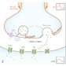

**Neuromuscular junction (NMJ)**

* **Definition**: a type of [chemical synapse](https://next.amboss.com/us/article/lp0vpS#Zedc2c888b2ab609e25b5a76884d52325) that occurs between [alpha motor neurons](https://next.amboss.com/us/article/G60BmS#Zcc61bf4b3ccd8b2cff7f6e5a657563f1) and [skeletal muscle](https://next.amboss.com/us/article/so0tWS#Z6f7ea6c70fce86b21d8ffeb1772bdfe0)
* **Motor unit**: an [alpha motor neuron](https://next.amboss.com/us/article/G60BmS#Zcc61bf4b3ccd8b2cff7f6e5a657563f1) together with the group of muscle fibers it innervates
* **Presynaptic**[**neuron**](https://next.amboss.com/us/article/lp0vpS#Zeb508d67af399f2b2da18e8b2cc5eed8): [action potential](https://next.amboss.com/us/article/9o0NVS#Z0988f6842348a3c63311140c08a28497) → [depolarization](https://next.amboss.com/us/article/9o0NVS#Zd4e0a1caa2f5d32a12799b9d4209249e) of the presynaptic membrane → opening of voltage-gated [Ca2+](https://next.amboss.com/us/article/Hg0K92#Z96f09f8b59b6467bac2f983358a263bb) channels → influx of [Ca2+](https://next.amboss.com/us/article/Hg0K92#Z96f09f8b59b6467bac2f983358a263bb) into the presynaptic terminal → [SNARE complex](https://next.amboss.com/us/article/lp0vpS#Zeaa09a4562fd5dc1b1beb63b4676b388)-mediated fusion of vesicles with the presynaptic membrane → release of [acetylcholine](https://next.amboss.com/us/article/lp0vpS#Z3c3ab1c3772cabdb26be3c413ba52df4) ([ACh](https://next.amboss.com/us/article/lp0vpS" \l "Z3c3ab1c3772cabdb26be3c413ba52df4)) from vesicles into the [synaptic cleft](https://next.amboss.com/us/article/lp0vpS#Z8fa6a37913ebcbc5593b41d7563ac73d)
* **Muscle fiber**: binding of [ACh](https://next.amboss.com/us/article/lp0vpS" \l "Z3c3ab1c3772cabdb26be3c413ba52df4) to its [receptor](https://next.amboss.com/us/article/qo0C1S#Z3ff0122a3c004eebed96e9db47e16ea4) on the postsynaptic membrane of muscle (motor end plate) → [depolarization](https://next.amboss.com/us/article/9o0NVS#Zd4e0a1caa2f5d32a12799b9d4209249e) of the postsynaptic membrane → end-plate potential (EPP) → stimulation of voltage-sensitive [dihydropyridine receptors](https://next.amboss.com/us/article/so0tWS#Z19b437be932bce5b7fea8c2ec2949c04) ([DHPR](https://next.amboss.com/us/article/so0tWS#Z19b437be932bce5b7fea8c2ec2949c04)) → coupling with [ryanodine receptors](https://next.amboss.com/us/article/so0tWS#Z0889e9d0c76e9772b6f4740631c400b9) (RR) → release of [Ca2+](https://next.amboss.com/us/article/Hg0K92#Z96f09f8b59b6467bac2f983358a263bb) from the [sarcoplasmic reticulum](https://next.amboss.com/us/article/so0tWS#Zbdb50e9cceca46b46083dbfd8c96618a) (SR) → [tropomyosin](https://next.amboss.com/us/article/so0tWS#Zf78038fae7eb96b2da8fd7efaf12e2df) releases the [myosin](https://next.amboss.com/us/article/so0tWS#Zc06ad117bf208c2c200d1f11533afd8f)-binding site on [actin](https://next.amboss.com/us/article/Lo0wcS#Z2984db7e143316fb81837a1585a0dd8e) → binding of [myosin](https://next.amboss.com/us/article/so0tWS#Zc06ad117bf208c2c200d1f11533afd8f) and [actin](https://next.amboss.com/us/article/Lo0wcS#Z2984db7e143316fb81837a1585a0dd8e) → muscle contraction
* [**Synaptic cleft**](https://next.amboss.com/us/article/lp0vpS#Z8fa6a37913ebcbc5593b41d7563ac73d): acetylcholinesterase (AChE) breaks down [ACh](https://next.amboss.com/us/article/lp0vpS" \l "Z3c3ab1c3772cabdb26be3c413ba52df4) → acetate and choline → reuptake of choline into the presynaptic membrane → resynthesis of [ACh](https://next.amboss.com/us/article/lp0vpS" \l "Z3c3ab1c3772cabdb26be3c413ba52df4)

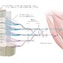

**Electrical synapses**

* A type of [synapse](https://next.amboss.com/us/article/lp0vpS#Zdcd1055abed8e01dc833605f76cb61ae) that transmits signals between [neurons](https://next.amboss.com/us/article/lp0vpS#Zeb508d67af399f2b2da18e8b2cc5eed8) joined by a [gap junction](https://next.amboss.com/us/article/Lo0wcS#Zb203dadec51ca5c9c73e4468fb336a6c) by the flow of electrical current (i.e., movement of ions).
* Unlike [chemical synapses](https://next.amboss.com/us/article/lp0vpS#Zedc2c888b2ab609e25b5a76884d52325), which require the transmission of a [neurotransmitter](https://next.amboss.com/us/article/lp0vpS#Z52019f1f39ac49ccfe9ec7e865d1766d) across a cleft, [electrical synapses](https://next.amboss.com/us/article/lp0vpS#Zfccf6590472f367e99370f7e39bf1e71) transmit the signal directly and without delay.
* Found in the [heart](https://next.amboss.com/us/article/Up0bKS#Z4e3e2c1885949b623580f92078d56c7d) and [smooth muscle](https://next.amboss.com/us/article/so0tWS#Z866ed9d8301f816f0335f83c58f7c562)
* Allows bidirectional flow of information between cells



NOTES

FEEDBACK

**Neurotrophic factors (NTFs)**

* **Definition**: substances that enhance neuronal survival and differentiation
* **Overview** [6][11][12]
  + [Neurons](https://next.amboss.com/us/article/lp0vpS#Zeb508d67af399f2b2da18e8b2cc5eed8) compete for survival-promoting agents during their development
  + NTFs ensure a match between the requirement for appropriate target innervation and the number of surviving [neurons](https://next.amboss.com/us/article/lp0vpS#Zeb508d67af399f2b2da18e8b2cc5eed8)
  + Functions include regulation of nervous system development (e.g., cell [proliferation](https://next.amboss.com/us/article/VP0GdT#Z2a4436e6b50383d2f3a205f11f9c829a), migration, differentiation, dendritic and axonal growth, synaptogenesis, synaptic plasticity), of regressive events (e.g., [cell death](https://next.amboss.com/us/article/VP0GdT#Zb3483fa4a700b90a3cd8ccb27fb6b899) or survival, [axon](https://next.amboss.com/us/article/lp0vpS#Z7a7039b9bbc6353245e697e51712c2c4) and [synapse](https://next.amboss.com/us/article/lp0vpS#Zdcd1055abed8e01dc833605f76cb61ae) elimination) after injury, and of [synaptic](https://next.amboss.com/us/article/lp0vpS#Zdcd1055abed8e01dc833605f76cb61ae) competition and by modifying both [synaptic transmission](https://next.amboss.com/us/article/lp0vpS#Z1bfc0864fad66774968660d4edf6f55a) and structure

MAXIMIZE TABLETABLE QUIZ

| **Overview of NTFs (trophic and growth factors) [6][12]** | | |
| --- | --- | --- |
| **Family** | **Examples** | **Functions** |
| **Neurotrophins** | * Nerve growth factor; brain-derived neurotrophic factor; neurotrophin 3, 4, and 5 | * Neuronal survival and differentiation * Involved in synaptic plasticity changes related to **learning and memory** |
| **Neuropoietic [cytokines](https://next.amboss.com/us/article/4p03pS" \l "Z1a9b57a2010f274f4a0f49e6010d30cf) and [interleukins](https://next.amboss.com/us/article/4p03pS" \l "Zb4024048bcbf5680d13f604db3d75a2d)** | * Ciliary neurotrophic factor, [leukemia](https://next.amboss.com/us/article/iT0Jq2#Zc0da5e32087bb9fdebbaad4515b11425) inhibitory factor, cardiotrophin like [cytokine](https://next.amboss.com/us/article/4p03pS#Z1a9b57a2010f274f4a0f49e6010d30cf)/[cytokine](https://next.amboss.com/us/article/4p03pS#Z1a9b57a2010f274f4a0f49e6010d30cf)-like factor * IL-1α, IL-1β, [IL-2](https://next.amboss.com/us/article/4p03pS#Z88b1138ac1486175490ecc18ddc74c39) – IL-15 | * Motor [neuron](https://next.amboss.com/us/article/lp0vpS" \l "Zeb508d67af399f2b2da18e8b2cc5eed8) survival * Immunoregulation |
| **Tissue growth factors** | * TGF-α, [TGF-β](https://next.amboss.com/us/article/qo0C1S#Zbe896b7d155f97a56f2f791612358e30), FGFs, [IGF](https://next.amboss.com/us/article/AT0Rt2#Zba4c9d41e1d28a6d43143de56c2074f7)-Iα, [IGF](https://next.amboss.com/us/article/AT0Rt2#Zba4c9d41e1d28a6d43143de56c2074f7)-Iβ, [IGF](https://next.amboss.com/us/article/AT0Rt2#Zba4c9d41e1d28a6d43143de56c2074f7)-II, [EGF](https://next.amboss.com/us/article/uo0pdS#Ze8e5addd44e86be195e7ce4a88f76b2e), [PDGF](https://next.amboss.com/us/article/qo0C1S#Ze49888d671d3bfd55b665cbfb238070e) | * Cell [proliferation](https://next.amboss.com/us/article/VP0GdT#Z2a4436e6b50383d2f3a205f11f9c829a) and differentiation in diverse tissues and organs * Effects on enteric, [dopaminergic](https://next.amboss.com/us/article/tN0X1g#Z0db70cd20a4945b51725d7adce664557), and motor [neurons](https://next.amboss.com/us/article/lp0vpS#Zeb508d67af399f2b2da18e8b2cc5eed8) |

NOTES

FEEDBACK

**References**

1.

Terasaki M. Axonal endoplasmic reticulum is very narrow. *J Cell Sci*. 2018; 131(4): p.jcs210450. doi: [10.1242/jcs.210450](https://dx.doi.org/10.1242/jcs.210450).[| Open in Read by QxMD](https://read.qxmd.com/doi/10.1242/jcs.210450)

2.

Glass JD, Wesselingh SL, Selnes OA, McArthur JC. Clinical-neuropathologic correlation in HIV-associated dementia. *Neurology*. 1993; 43(11): p.2230-2230. doi: [10.1212/wnl.43.11.2230](https://dx.doi.org/10.1212/wnl.43.11.2230).[| Open in Read by QxMD](https://read.qxmd.com/doi/10.1212/wnl.43.11.2230)

3.

Raikwar SP, Bhagavan SM, Ramaswamy SB, et al. Are Tanycytes the Missing Link Between Type 2 Diabetes and Alzheimer’s Disease?. *Mol Neurobiol*. 2018; 56(2): p.833-843. doi: [10.1007/s12035-018-1123-8](https://dx.doi.org/10.1007/s12035-018-1123-8).[| Open in Read by QxMD](https://read.qxmd.com/doi/10.1007/s12035-018-1123-8)

4.

Felten DL, O'Banion MK, Maida ME. *Netter's Atlas of Neuroscience*. Amsterdam, The Netherlands: Elsevier Health Sciences; 2015

5.

Jessen KR, Mirsky R. The repair Schwann cell and its function in regenerating nerves. *J Physiol*. 2016; 594(13): p.3521-3531. doi: [10.1113/jp270874](https://dx.doi.org/10.1113/jp270874).[| Open in Read by QxMD](https://read.qxmd.com/doi/10.1113/jp270874)

6.

Squire L, Berg D, Bloom FE, du Lac S, Ghosh A, Spitzer NC. *Fundamental Neuroscience*. Academic Press; 2013

7.

Marios Politis, Flavia Niccolini. Serotonin in Parkinson's disease. *Behav Brain Res*. 2015; 277: p.136-145. doi: [10.1016/j.bbr.2014.07.037](https://dx.doi.org/10.1016/j.bbr.2014.07.037).[| Open in Read by QxMD](https://read.qxmd.com/doi/10.1016/j.bbr.2014.07.037)

8.

Tarsa L, Goda Y. Synaptophysin regulates activity-dependent synapse formation in cultured hippocampal neurons. *Proceedings of the National Academy of Sciences*. 2002; 99(2): p.1012-1016. doi: [10.1073/pnas.022575999](https://dx.doi.org/10.1073/pnas.022575999).[| Open in Read by QxMD](https://read.qxmd.com/doi/10.1073/pnas.022575999)

9.

Hammond C, El Far O, Seagar M. *Neurotransmitter release*. Elsevier; 2015: p. 145-169

10.

Purves. Neuroscience. <https://www.ncbi.nlm.nih.gov/books/NBK11117/>. Updated: January 1, 2001. Accessed: January 7, 2022.

11.

Huang EJ, Reichardt LF. Neurotrophins: Roles in Neuronal Development and Function. *Annu Rev Neurosci*. 2001; 24(1): p.677-736. doi: [10.1146/annurev.neuro.24.1.677](https://dx.doi.org/10.1146/annurev.neuro.24.1.677).[| Open in Read by QxMD](https://read.qxmd.com/doi/10.1146/annurev.neuro.24.1.677)

12.

Siegel GJ, Agranoff BW, Albers RW et al. *Basic Neurochemistry: Molecular, Cellular and Medical Aspects*. Philadelphia, PA, USA: Lippincott-Raven; 1999